AI – POWERED SOC & DIGITAL FORENSICS

WEEK – 2 : (SIEM AND THREAT DETECTION)
PROJECT – 4 : (attack detection - detect a brute – force attack patterns using SIEM dashboards and generate a basic report)

INTRODUCTION
Brute-force attacks are one of the most common cybersecurity threats faced by organizations today. In this type of attack, an attacker repeatedly tries different usernames and passwords in an attempt to gain unauthorized access to a system.
In this project, using the Wazuh SIEM platform to detect brute-force SSH attack patterns. Authentication logs generated by the Linux system were monitored in real time, and suspicious login activities were analyzed using the Wazuh Dashboard.
Mainly focused on ,Monitoring SSH authentication logs , Simulating repeated failed login attempts , Detecting brute-force attack behavior , Generating automated security alerts , Analyzing attack patterns using SIEM dashboards

OBJECTIVES
The main objectives of this project are:
- To understand the behavior of brute-force attacks
- To monitor SSH authentication logs using Wazuh
- To simulate failed SSH login attempts
- To detect suspicious login patterns using SIEM dashboards
- To analyze alerts generated by Wazuh

TOOLS :

Wazuh SIEM | Used for security monitoring and alert management
Kali Linux | Used as the host operating system
Oracle VM VirtualBox | Used to create the virtual environment
SSH Service | Used for authentication testing
Linux Authentication Logs | Source of security-related events
Wazuh Dashboard | Used for visualization and security analysis

PROJECT ARCHITECTURE
1. Linux System
2. SSH Server
3. Wazuh Manager
4. Wazuh Rules Engine
5. Wazuh Dashboard

STEP 1: WAZUH CONFIGURATION
Students installed and configured the Wazuh Manager on Kali Linux.
Steps :
- Started Wazuh Manager services
- Enabled authentication log monitoring
- Verified SSH logging configuration
- Accessed the Wazuh web dashboard
This setup ensured that Wazuh was ready to collect and analyze authentication logs.

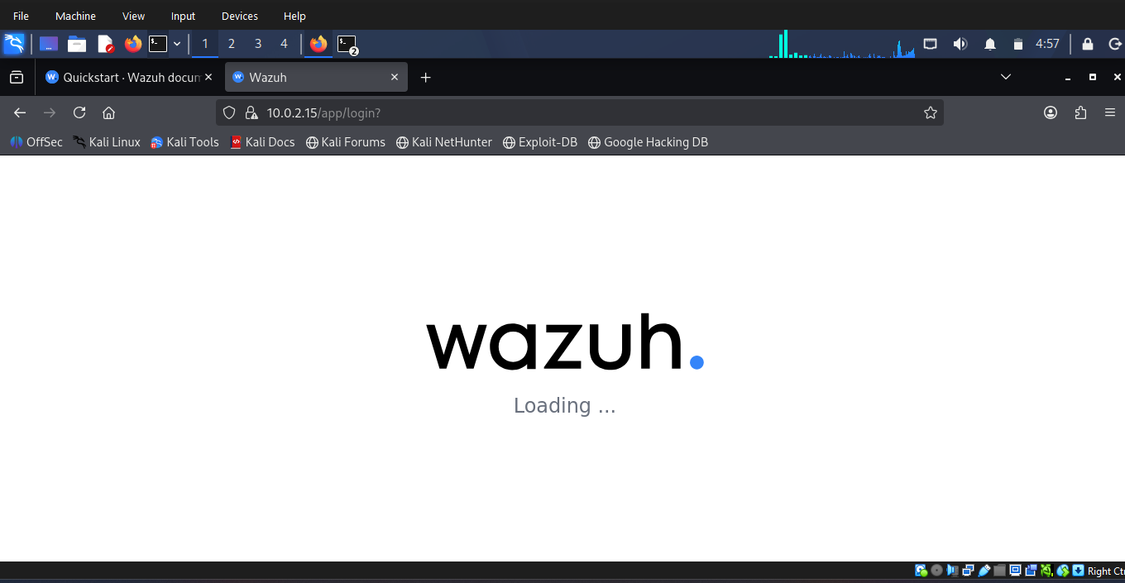
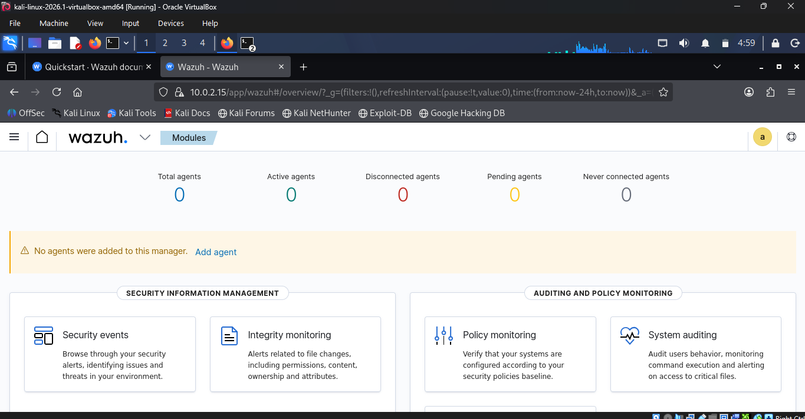

STEP 2: SIMULATING A BRUTE-FORCE ATTACK
a brute-force SSH attack by generating multiple failed login attempts using an invalid username.
Command Used
for i in {1..20}; do ssh -o ConnectTimeout=2 -o NumberOfPasswordPrompts=1 wronguser@localhost; done
Purpose of the Command
This command:
- Repeatedly attempted SSH login using an invalid username
- Simulated brute-force password guessing behavior
- Generated multiple failed authentication events
- Helped Wazuh detect suspicious login patterns
The repeated login failures created attack-like behavior inside the authentication logs.
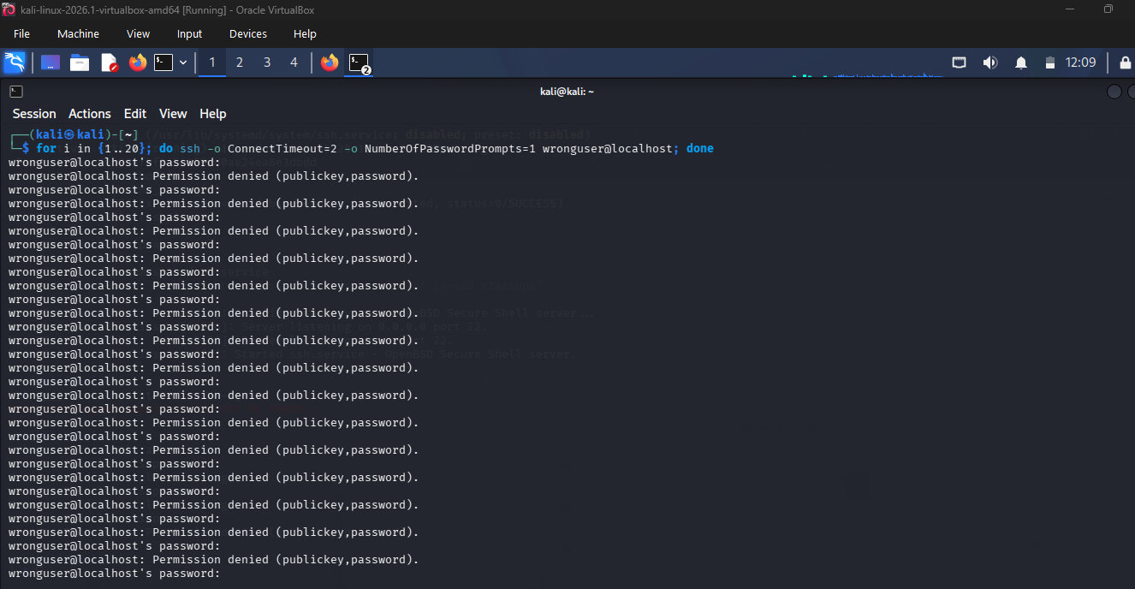

TERMINAL-BASED ATTACK SIMULATION
repeated SSH login failures using the username: wronguser@localhost
Observations
- Multiple login attempts were generated continuously
- SSH returned the message:
Permission denied (publickey,password)
- This confirmed that the login attempts failed successfully
- The repeated failures created brute-force attack patterns in the logs

Wazuh Security Events Dashboard
The Wazuh Dashboard successfully detected the suspicious authentication activity.
Dashboard Findings
Event | Value
Total Alerts | 72
Authentication Failures | 72
Authentication Success | 0
Level 12+ Alerts | 0

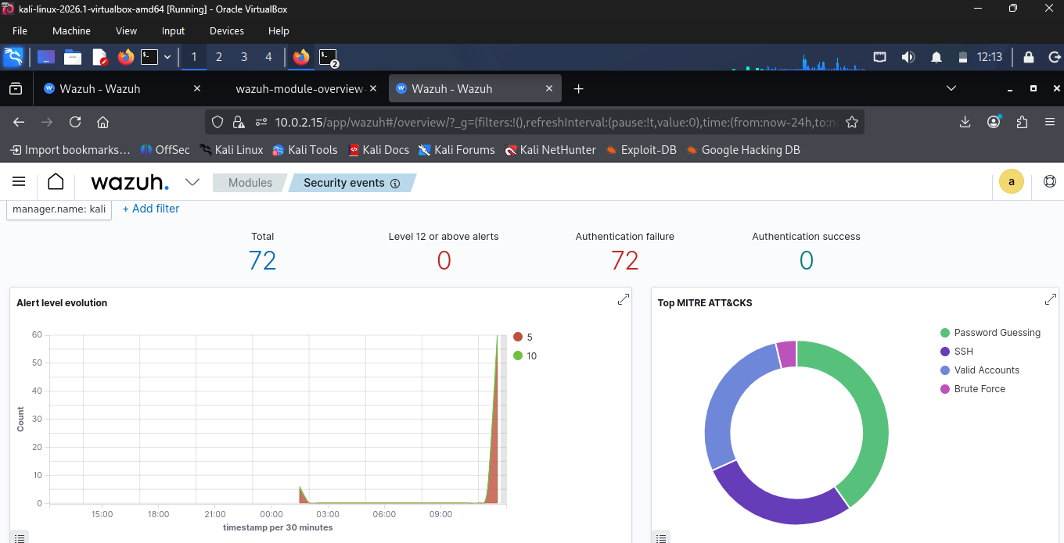

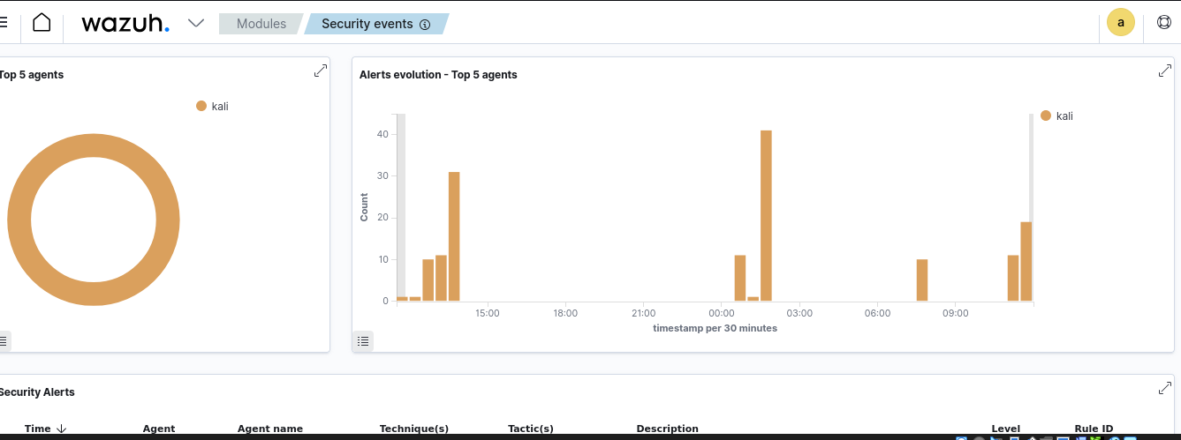

MITRE ATT&CK CLASSIFICATION
The dashboard mapped the detected activity to the following attack techniques:
- Password Guessing
- SSH Abuse
- Brute Force
- Valid Accounts

ALERT EVOLUTION
The dashboard graph showed a sudden increase in authentication failures over a short period.
This clearly indicated suspicious login activity and possible brute-force behavior.

WAZUH ALERT ANALYSIS
The Wazuh platform generated several important security alerts during the attack simulation.
Rule ID | Description | Level | Count
5710 | SSH login using non-existent user | 5 | 46
5503 | PAM user login failed | 5 | 20
2502 | Multiple incorrect password attempts | 10 | 2
5551 | Multiple failed logins within a short period | 10 | 2
5712 | SSH brute-force attack detected | 10 | 2
These alerts confirmed that Wazuh successfully identified suspicious login behavior.

The report will be provided by an wazuh ,
CONCLUSION
This project demonstrated how the Wazuh SIEM platform can effectively detect brute-force SSH attacks using authentication logs and rule-based alerting. Overall, Wazuh proved to be an efficient and reliable platform for detecting authentication-based cyberattacks in Linux environments.

